KUNSTMUSEUM MUSTERHOUSE
Artwork Inventory Number / Lender’s Abbreviation
Exhibition Room No. //Great for incoming loans//
KUNSTMUSEUM MUSTERHOUSE
Inv. PPI-2010-068 / PACGAL
Exhibition Room No. 1

KUNSTMUSEUM MUSTERHOUSE
Inv. AWA-2023-001 / KMLUCE
Exhibition Room No. 2

KUNSTMUSEUM MUSTERHOUSE
Inv. AGI-2016-010 / WHINYC
Exhibition Room No. 3

KUNSTMUSEUM MUSTERHOUSE
Inv. CMO-1990-057 / NCGAL
Exhibition Room No. 4

KUNSTMUSEUM MUSTERHOUSE
Artist Name, Inventory Number
Title of the Artwork //Great for items in the museum collection//
Crate size: Length x Depth x Height, Weight
KUNSTMUSEUM MUSTERHOUSE
Pablo PICASSO, Inv. PPI-2010-068
Guitarriste
Crate size: 160 x 46 x 150 (H) cm, 157 KG
KUNSTMUSEUM MUSTERHOUSE
Andy WARHOL, Inv. AWA-2023-001
Double Marylin
Crate size: 110 x 40 x 110 (H) cm, 125 KG
KUNSTMUSEUM MUSTERHOUSE
Alberto GIACOMETTI, Inv. AGI-2016-010
Three Men Walking
Crate size: 250 x 90 x 90 (H) cm, 245 KG
KUNSTMUSEUM MUSTERHOUSE
Claude MONET, Inv. CMO-1990-057
Paysage
Crate size: 85 x 40 x 85 (H) cm, 90 KG

KUNSTMUSEUM MUSTERHOUSE
Artist Name, Inventory Number
Title of the Artwork, year //Great for items in the museum collection//
Technique, artwork dimensions
KUNSTMUSEUM MUSTERHOUSE
Pablo PICASSO, Inv. PPI-2010-068
Guitarriste, 1926
Oil on canvas, 120 x 90 cm
KUNSTMUSEUM MUSTERHOUSE
Andy WARHOL, Inv. AWA-2023-001
Double Marylin, 1969
Silkscreen on canvas, 90 x 90 cm
KUNSTMUSEUM MUSTERHOUSE
Alberto GIACOMETTI, Inv. AGI-2016-010
Three Men Walking, 1948
Bronze, 230 x 70 x 70 cm
KUNSTMUSEUM MUSTERHOUSE
Claude MONET, Inv. CMO-1990-057
Paysage, 1879
Oil on canvas, 40 x 60 cm

KUNSTMUSEUM MUSTERHOUSE  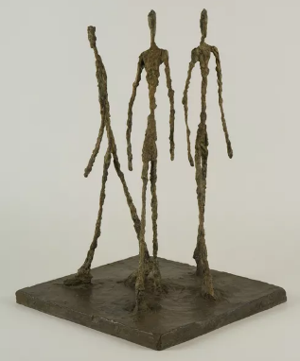  Inventory Number  Artist Name  Artwork Title, Year  Technique  Dimensions | KUNSTMUSEUM MUSTERHOUSE  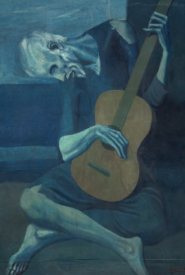  PPI-2010-068  Pablo PICASSO  Guitarriste, 1926  Oil on canvas  120 x 90 cm
KUNSTMUSEUM MUSTERHOUSE  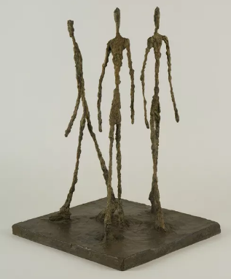  AGI-2016-010  Alberto GIACOMETTI  Three Men Walking, 1948  Bronze  230 x 70 x 70 cm | KUNSTMUSEUM MUSTERHOUSE  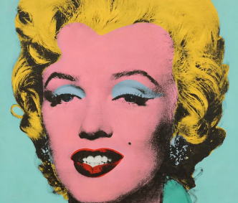  AWA-2023-001  Andy WARHOL  Double Marilyn, 1969  Silkscreen on canvas  90 x 90 cm
KUNSTMUSEUM MUSTERHOUSE  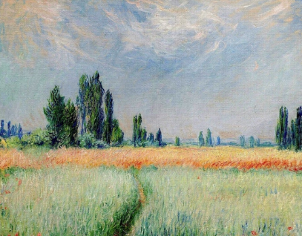  CMO-1990-057  Claude MONET  Paysage, 1879  Oil on canvas  40 x 60 cm | KUNSTMUSEUM MUSTERHOUSE  Inventory Number  Artist Name  Artwork Title, Year  Technique  Dimensions
KUNSTMUSEUM MUSTERHOUSE  Inventory Number  Artist Name  Artwork Title, Year  Technique  Dimensions | KUNSTMUSEUM MUSTERHOUSE  Inventory Number  Artist Name  Artwork Title, Year  Technique  Dimensions
KUNSTMUSEUM MUSTERHOUSE  Inventory Number  Artist Name  Artwork Title, Year  Technique  Dimensions | KUNSTMUSEUM MUSTERHOUSE  Inventory Number  Artist Name  Artwork Title, Year  Technique  Dimensions

